

**NEXT GEN EMPLOYABILITY PROGRAM**

**Creating a future**

**-**

**ready workforce**

**………………………………………...............**

**Team Members**

**Student Name :MOHANAPRIYA M**

**Student ID**

**: au613021104051**

**………………………………………...............**

**College Name**

**VIVEKANANDHA COLLEGE OF**

**TECHNOLOGY FOR WOMEN**

**CAPSTONE PROJECT SHOWCASE**

**Notes Sharing Web Application using Django Framework**

**Project Title**

Abstract | Problem Statement | Project Overview | Proposed Solution |

Technology Used | Modelling & Results | Conclusion

# Abstract

Our project focuses on creating an innovative notes sharing web application utilizing Python and Django technologies. The platform provides a centralized hub for users to create, share, and collaborate on notes, fostering a dynamic learning ecosystem. With a focus on user privacy and data security, the application employs robust encryption and access control mechanisms, ensuring confidentiality and integrity of shared content.

# Problem Statement

|  |
| --- |
| Next Gen Employability Program |

**Access Control and Permissions :** Implement access control and permission management functionalities, allowing users to control who can view, edit, and share their notes, ensuring privacy and data security.



# Project Overview

The proposed solution aims to develop a robust notes sharing web application using Python with the Django framework. This application will facilitate seamless sharing and collaboration on notes among users, providing a user-friendly interface and robust security measures.

Our Notes Sharing Web Application built on Python with the Django framework has laid a strong foundation for collaborative note-taking and sharing. However, to ensure its continued relevance and competitiveness in the ever-evolving landscape of digital collaboration tools, we propose several future enhancements aimed at enriching user experience, enhancing functionality, and optimizing performance.

# Proposed Solution

* Implement a robust search functionality allowing users to easily find specific notes based on keywords, tags, or categories.
* Provide users with customizable profiles where they can manage their preferences, view shared notes, and connect with other users.
* Employ best practices for security, including encryption of sensitive data, protection against common web vulnerabilities such as CSRF and XSS attacks, and secure storage of user credentials.
* Develop a responsive web design ensuring the application is accessible and functional across various devices and screen sizes.
* Provide an admin dashboard with tools to manage users, monitor activity, and moderate content.

# Technologies Used

**Frontend Backend**

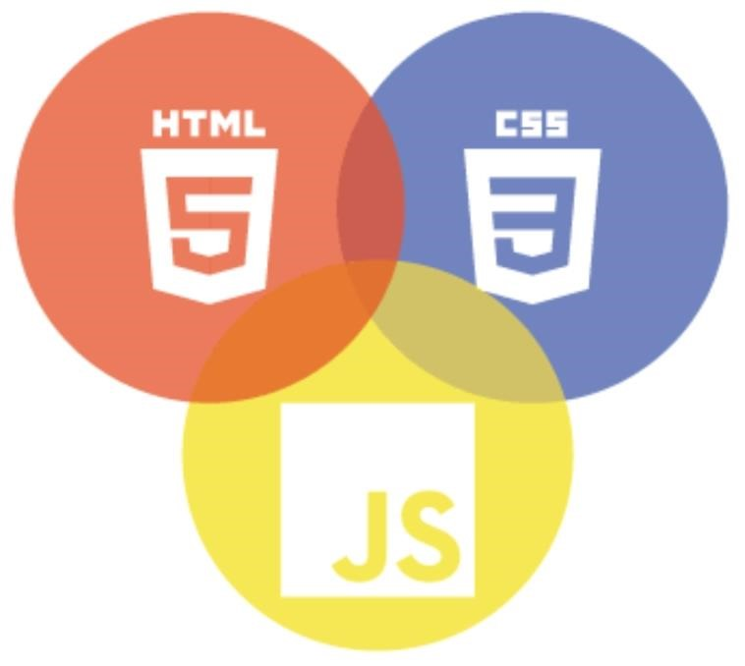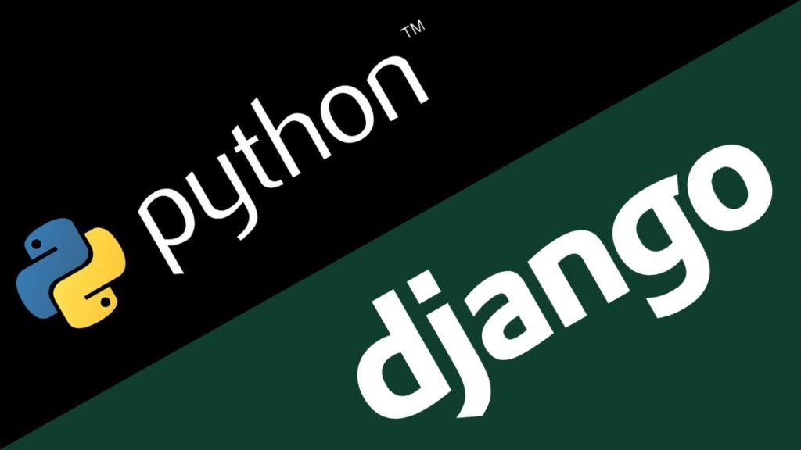

# Modelling & Results

* **Python:** Utilize Python as the primary programming language for backend development due to its simplicity, versatility, and extensive libraries.
* **Django Framework:** Leverage the Django framework for rapid development, built-in security features, and scalability.
* **HTML/CSS/JavaScript:** Use these technologies for frontend development to create an intuitive and interactive user interface.
* **SQLite/PostgreSQL:** Employ SQLite during development for its simplicity and switch to PostgreSQL for production for better scalability and performance.
* **RESTful API:** Develop a RESTful API to facilitate communication between the frontend and backend, enabling seamless integration with other platforms and services.

**Home Page**

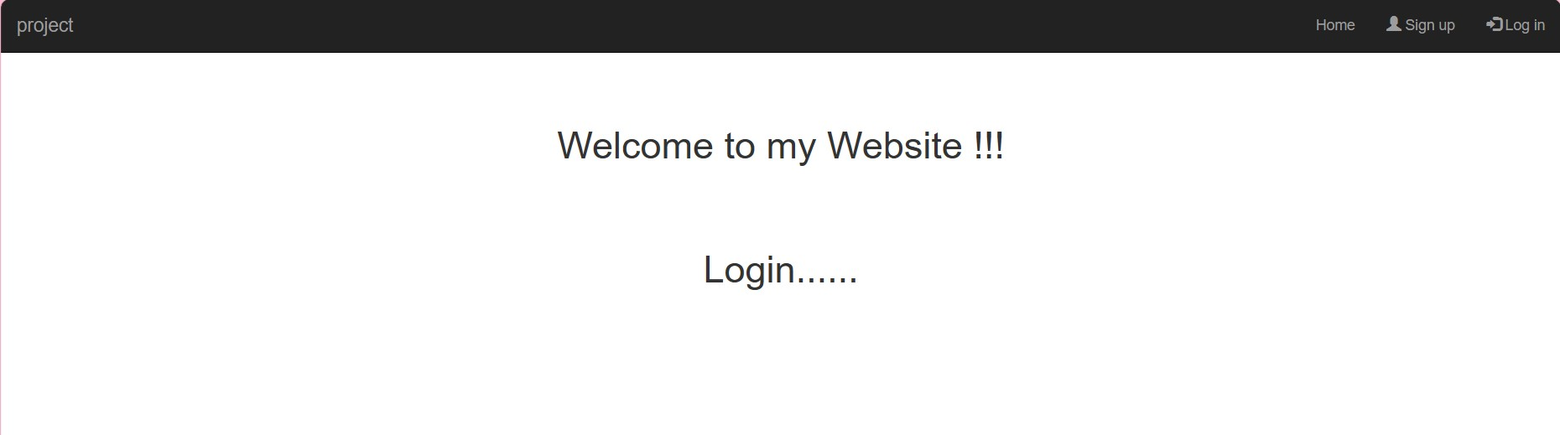

**SignUp Page**

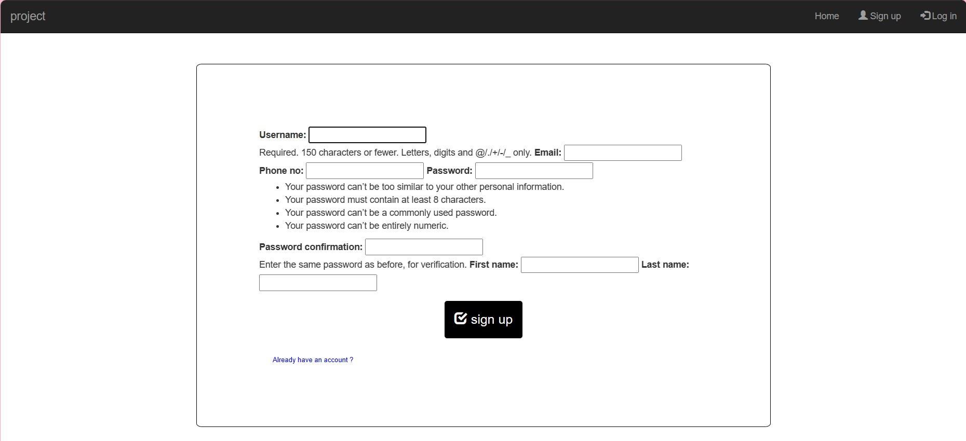

**Login Page**

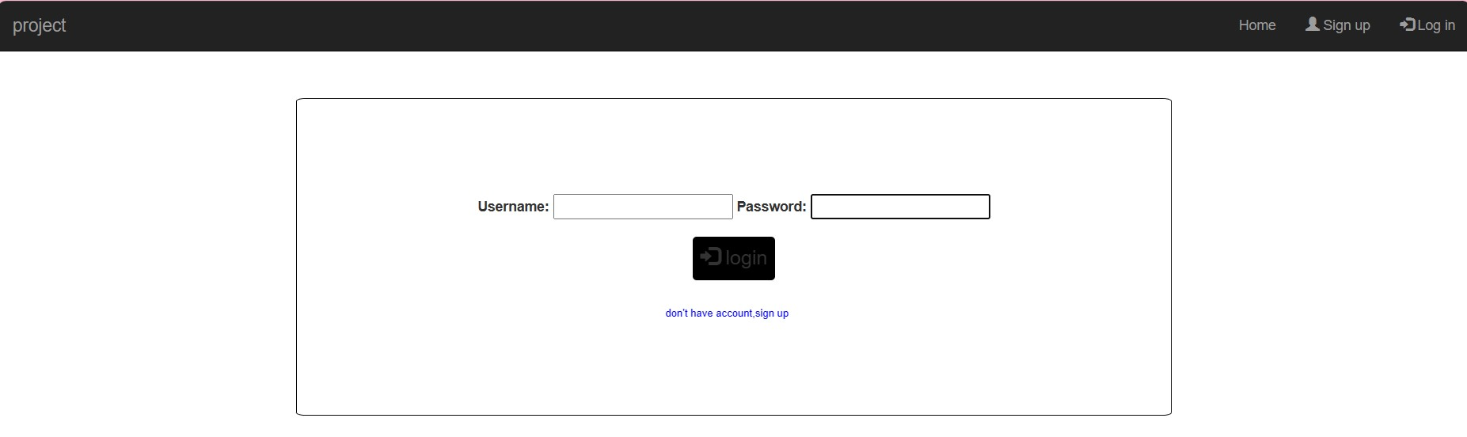

**Files Uploading Page**

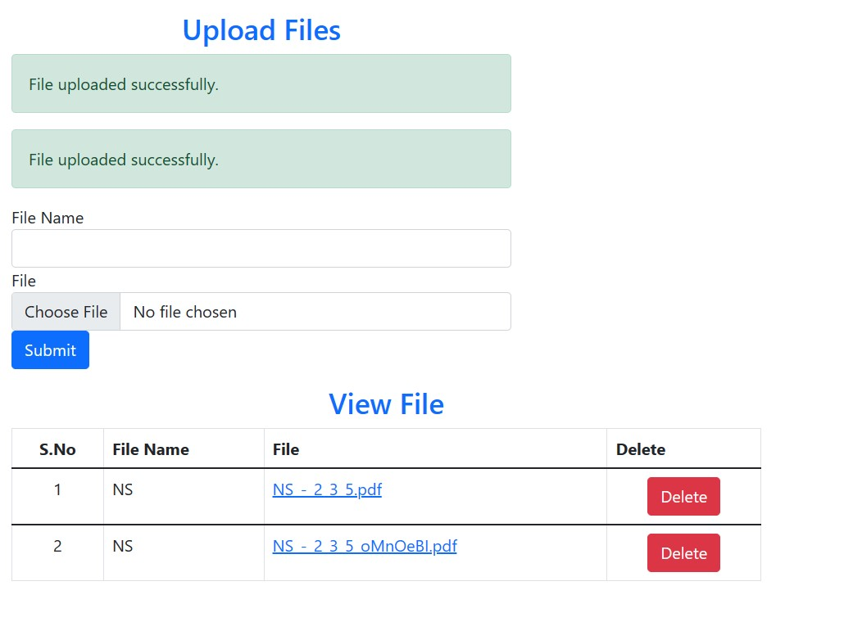

**Files Deleting Page**

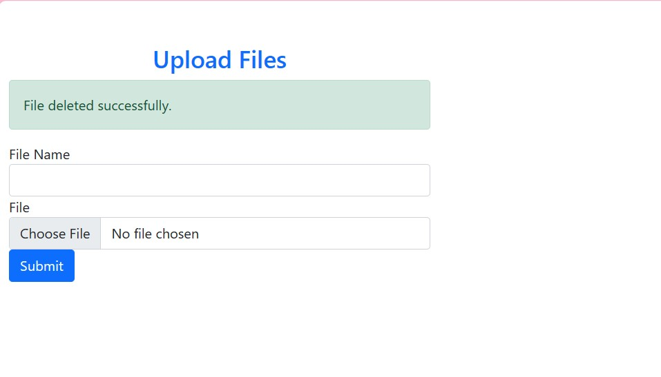

# Future Enhancements

Personalization and Customization:

1. Enable users to personalize their note-taking experience by customizing themes, layouts, and preferences.
2. Allow users to create custom categories, tags, or folders to organize their notes more efficiently.

Offline Access and Sync:

1. Develop an offline mode feature, allowing users to access and edit notes even when not connected to the internet.
2. Implement synchronization mechanisms to automatically sync changes made offline once the user reconnects to the internet.

# Conclusion

|  |
| --- |
| Next Gen Employability Program |

The Notes Sharing Web Application is poised to revolutionize the way users create, manage, and share notes online. With its intuitive interface, powerful features, and robust architecture, the application promises to streamline workflows, foster collaboration, and elevate productivity. Through continuous improvement and user feedback, we aim to create a platform that meets the evolving needs of our users and remains a valuable tool for personal and professional use.

|  |
| --- |
| Next Gen Employability Program |

**Thank You !**

